**Question 1**

Create a database ’Hollywood’, Table Movie- auto increment, pk.

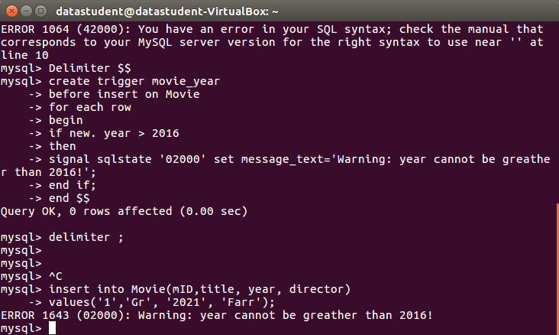5. The ’year’ column in the Movie table should not be greater than 2016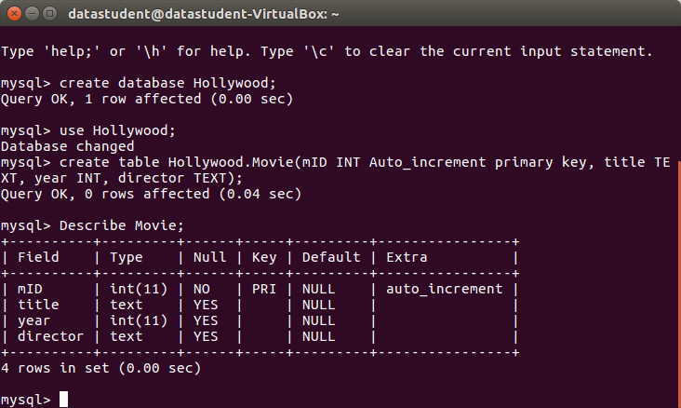

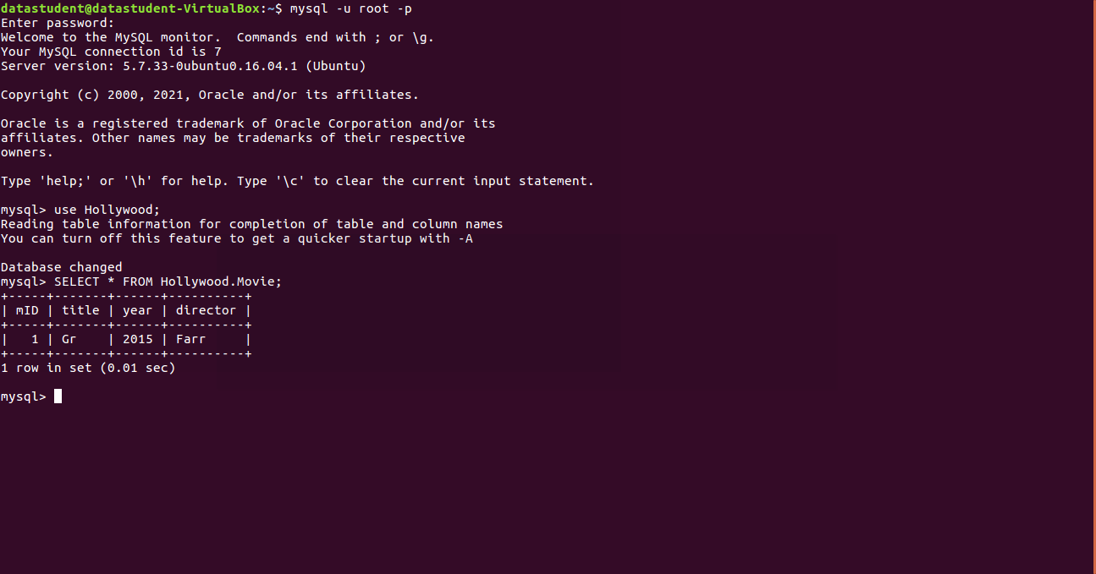**Creating Tables Reviewer and Reting –placing auto increment, pk’s,** default value of the ’ratingDate’ column (as type timestamp and default current_timestamp)

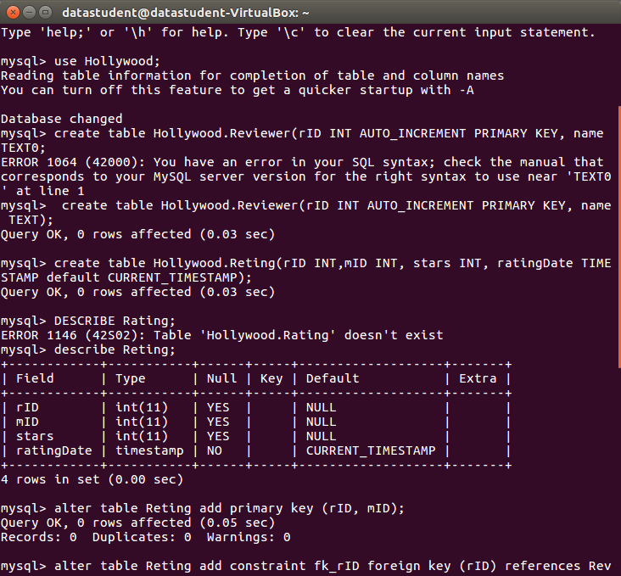

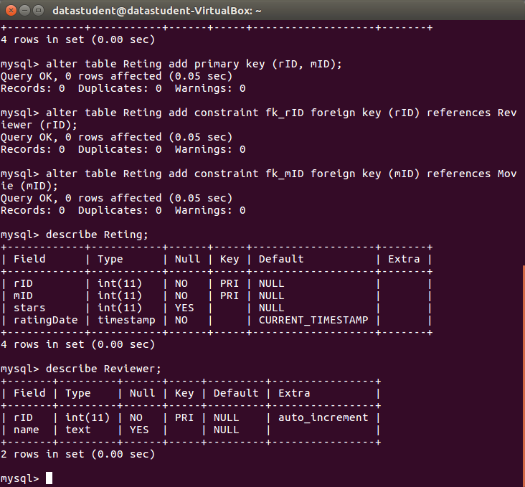**Adding Constrains FK’s**

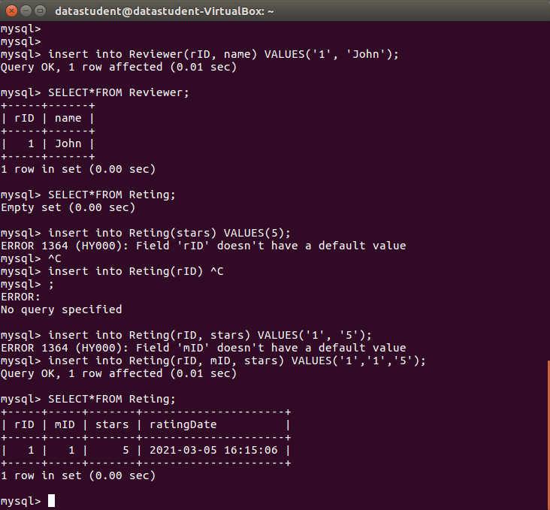**Inserting Values to Reviewer ad Reting**

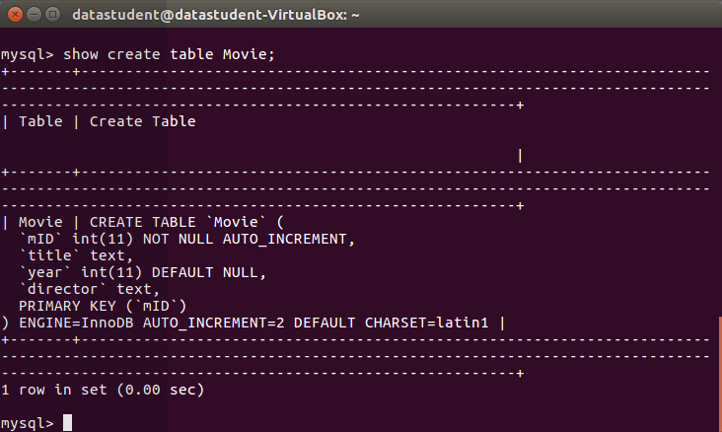**Showing all tables:**

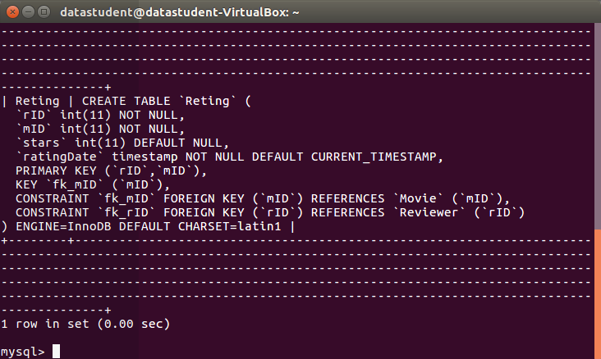

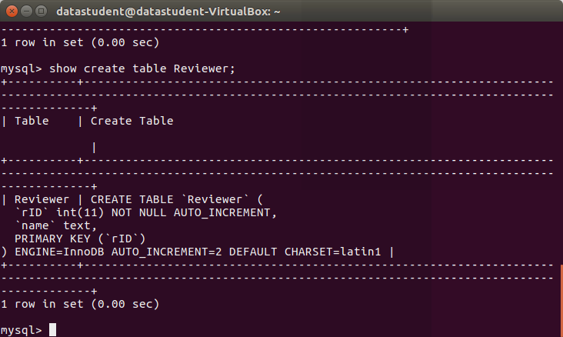

**Question 2**

Executing the script:

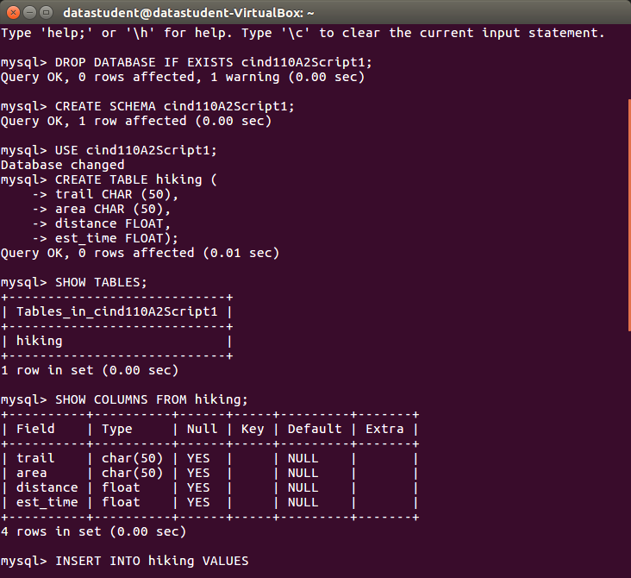

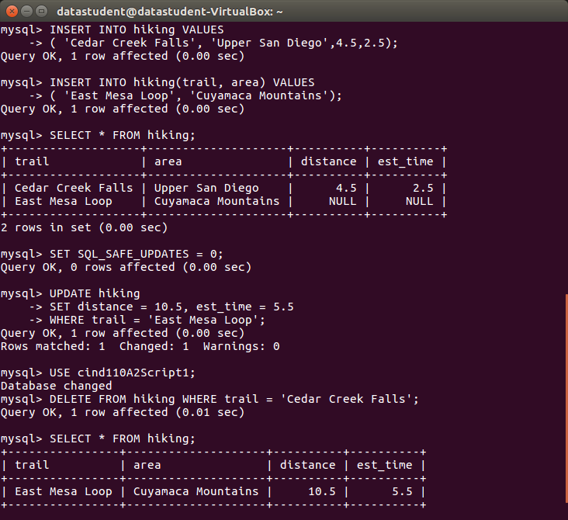

1. Write the SQL statements to insert the values into the hiking table:
2. Write the SQL statements to update the entry 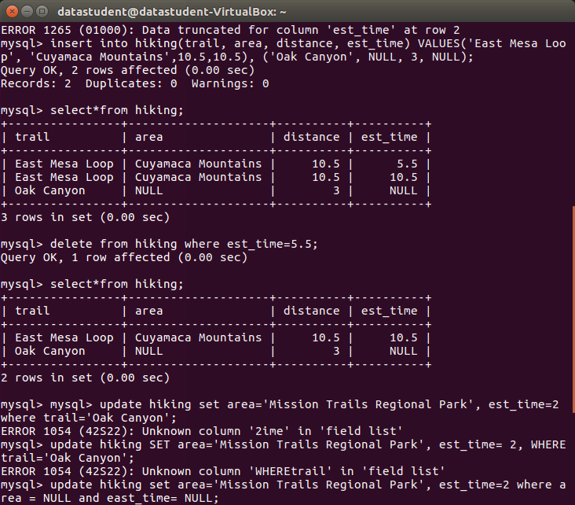for Oak Canyon

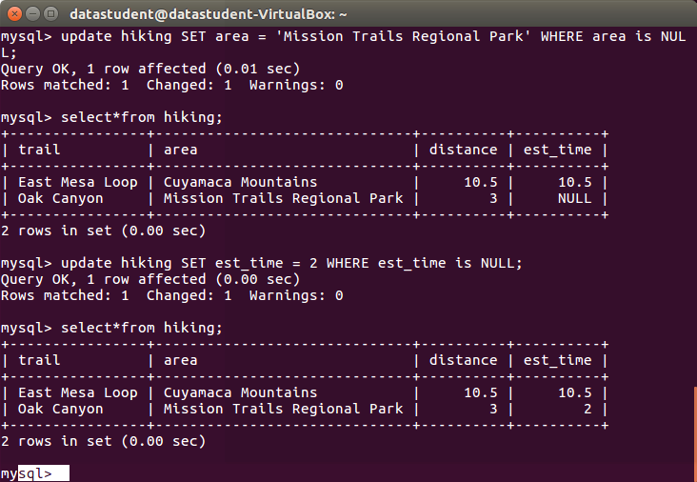

1. Write the SQL statement to delete trails with a distance greater than 5 miles.
2. Write the SQL statement to create a table called ’rating’.

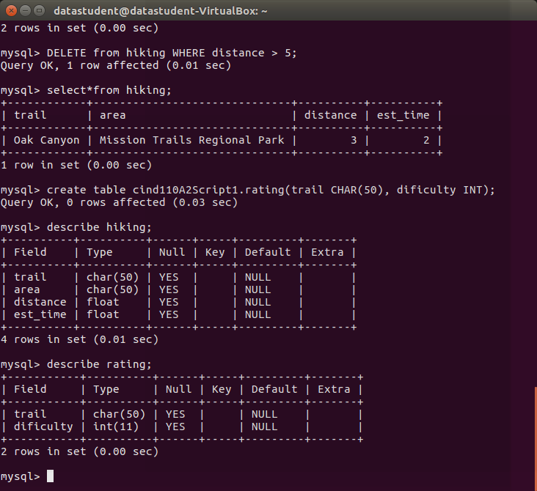

5. Write the command to add another column to the hiking table called ’trailID’ with Primary key

constraint.

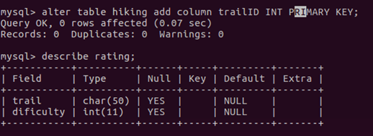

6. Add another column called ’trailID’ in the ’rating’ table and adding Constrains.

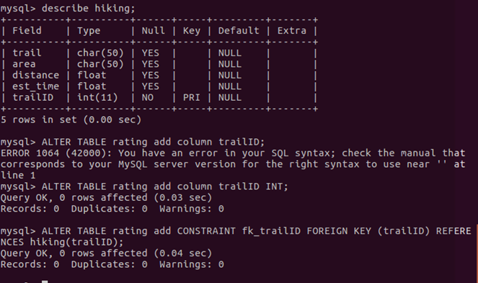

7. What is the command to delete the rating table?   
(See at the bottom)

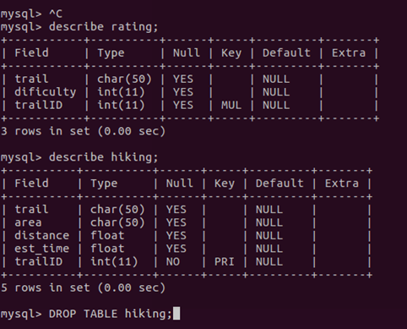

**Question 3**

**(Please make word file bigger (+ ) to see better the screenshots from mysql work bench)**

**Creating database CustOrders and adding tables Customer, Salesman and Order entities, constrains, inserting data:**

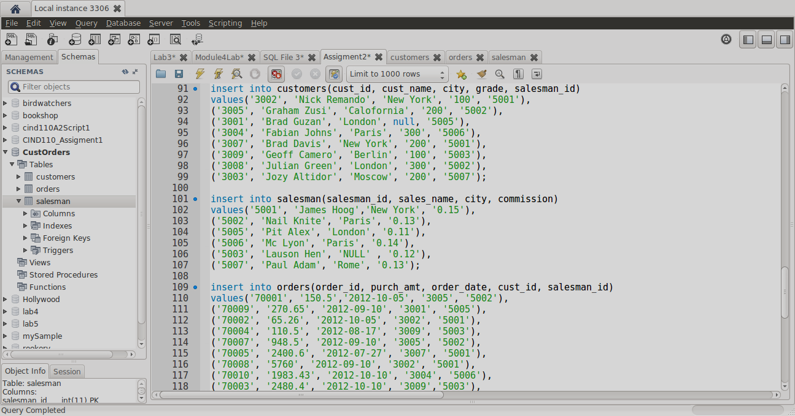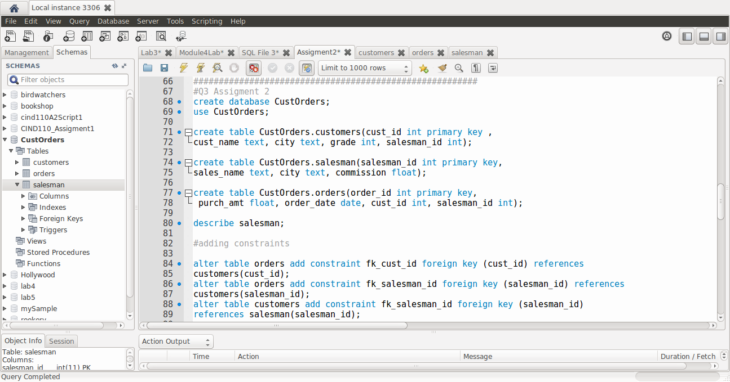

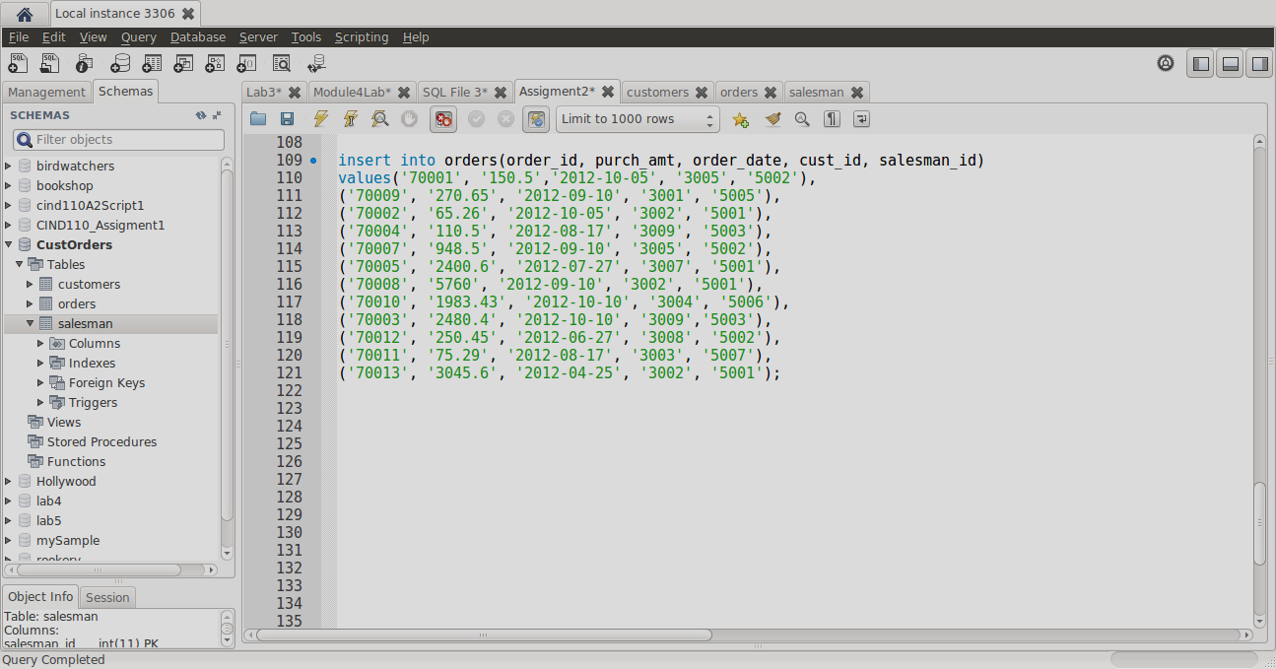

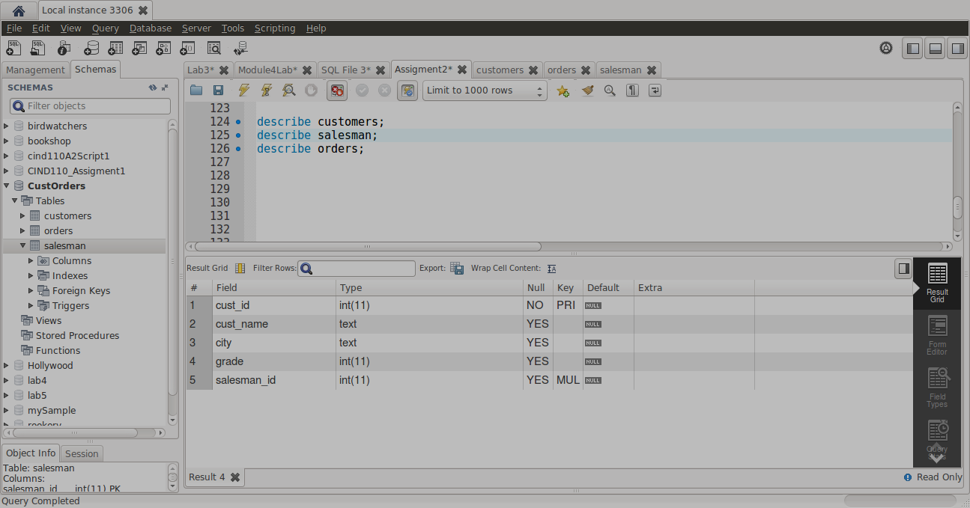

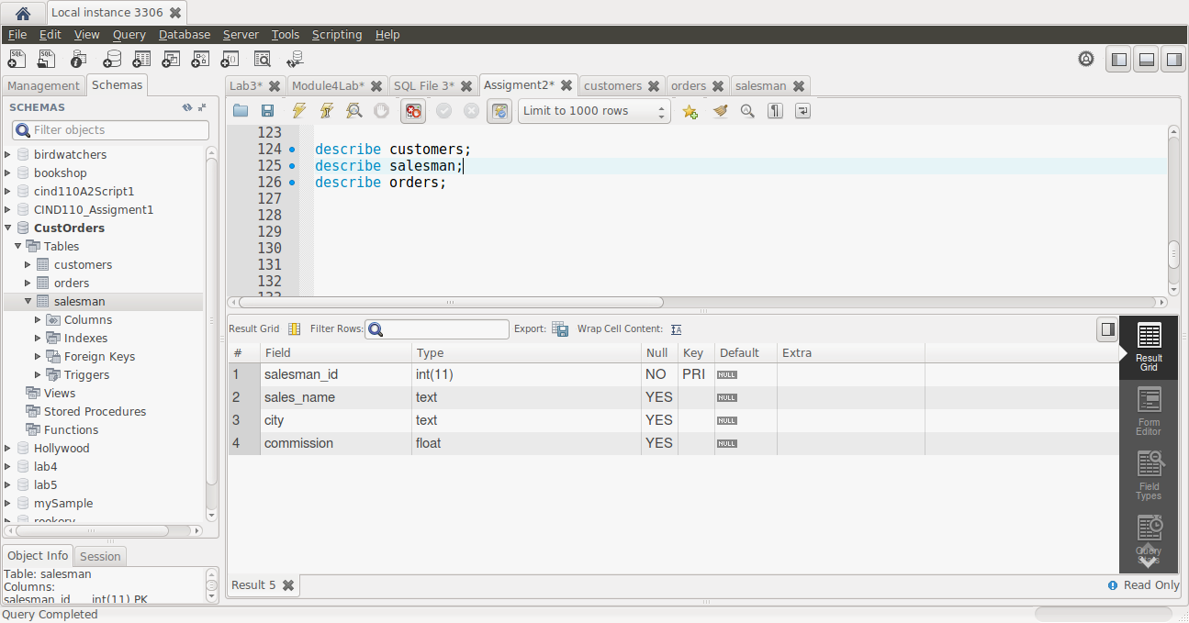

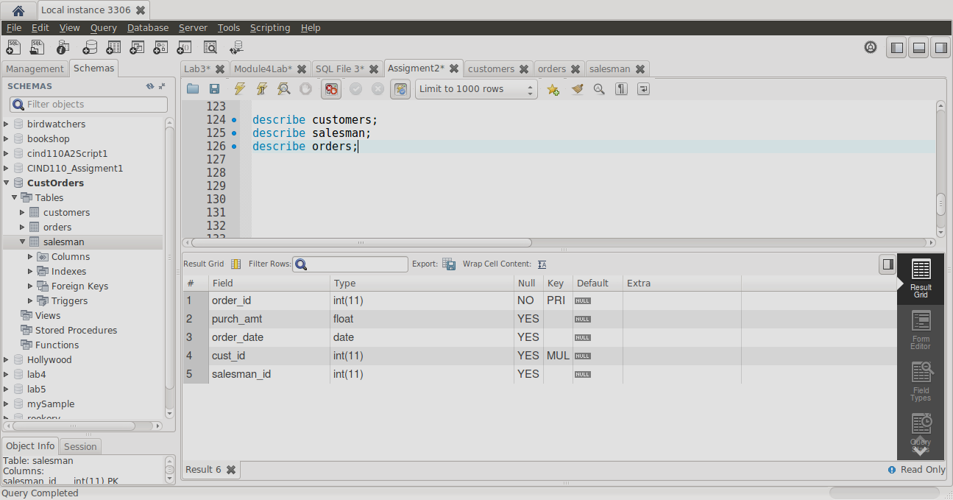

1. Write an SQL statement to prepare a list with salesman name, customer name and their cities for

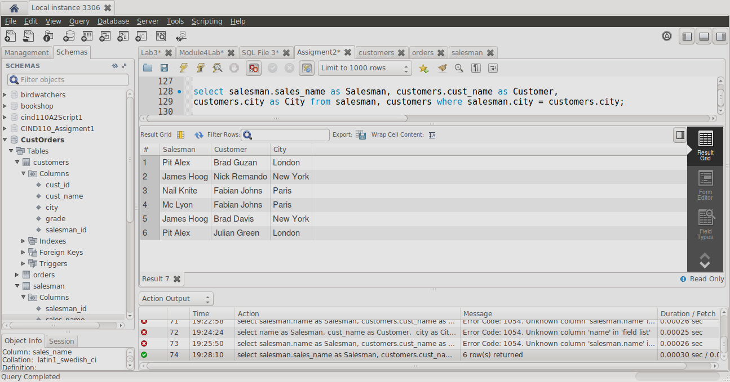the salesmen and customer who belong to same city.

2. Write an SQL statement to make a list with order no, purchase amount, customer name and their

cities for the orders where order amount is between 500 and 2000.

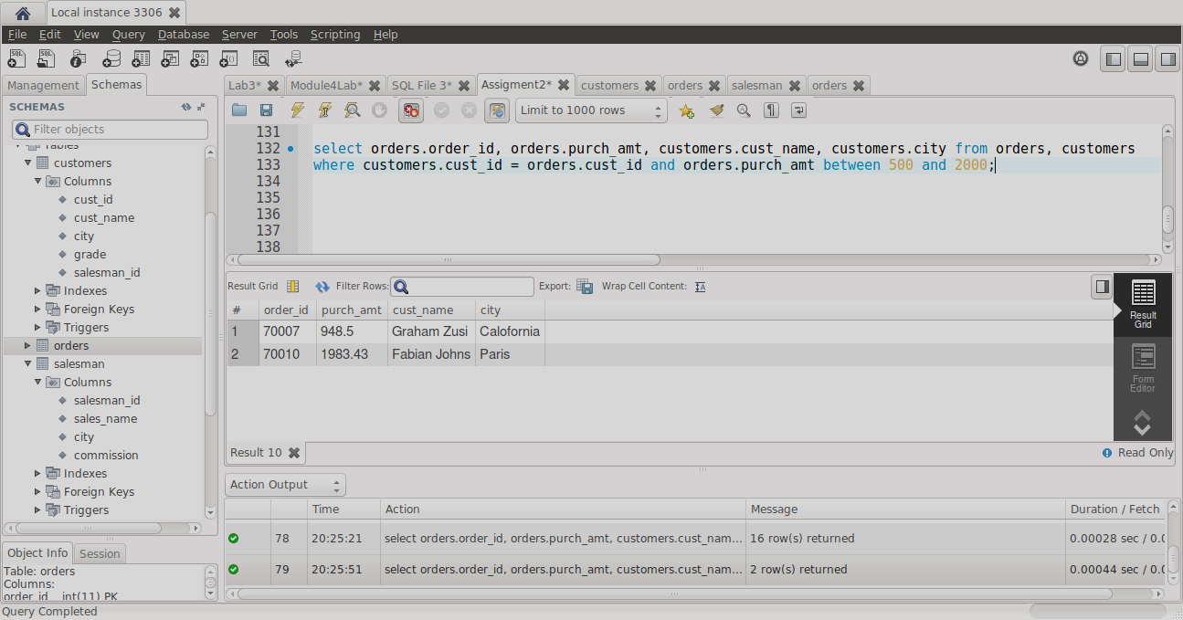

3. Write an SQL statement to find out which salesmen are working for which customer.

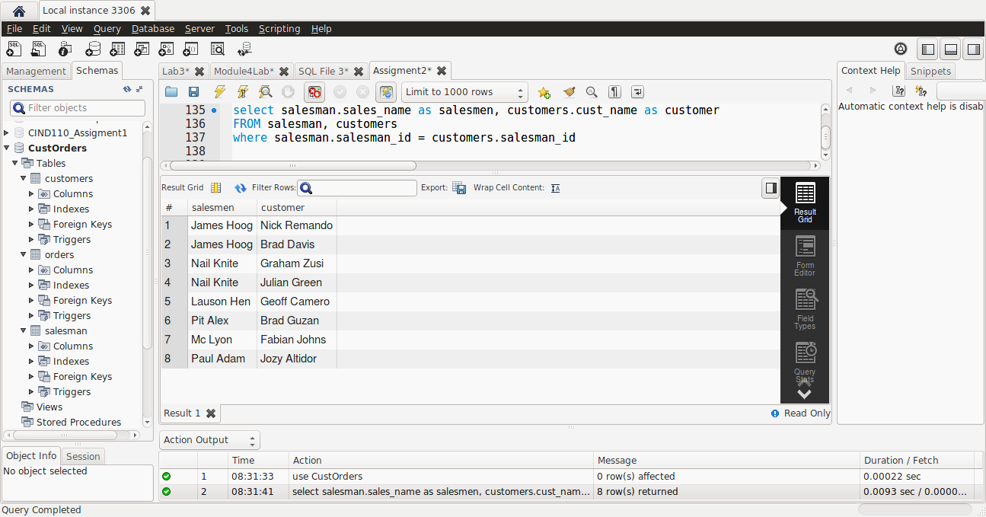

4. Write an SQL statement to find the list of customers who appointed a salesman for their jobs whose

commission is more than 12%.

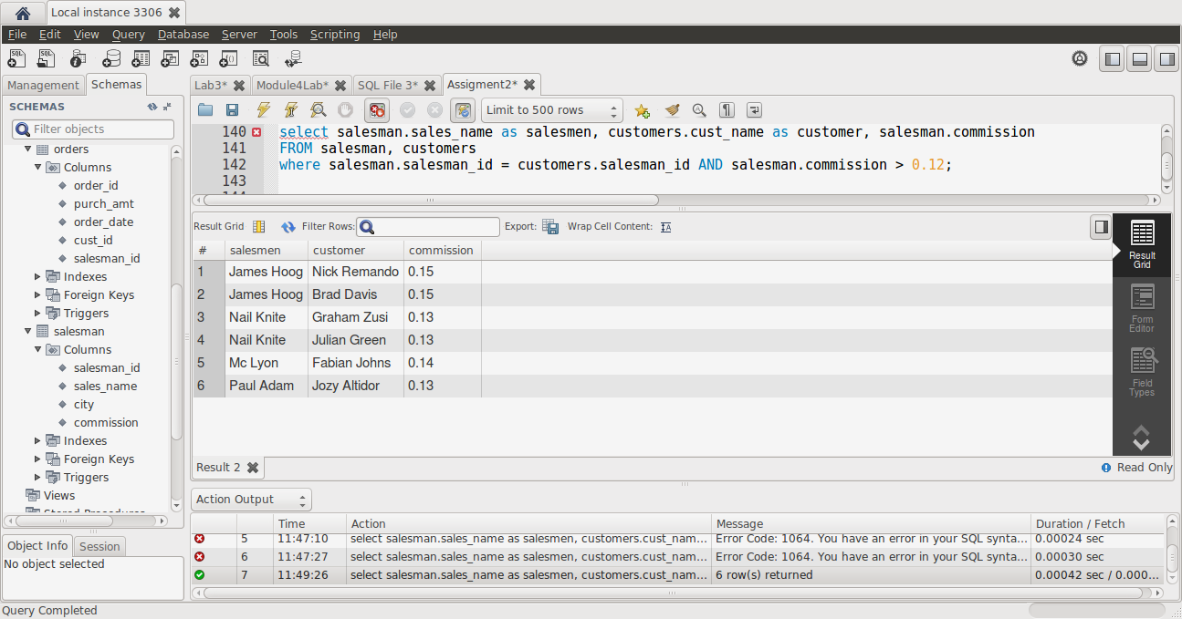

5. Write an SQL statement to find the list of customers who appointed a salesman for their jobs who

does not live in same city where the customer lives, and gets a commission above 12%.

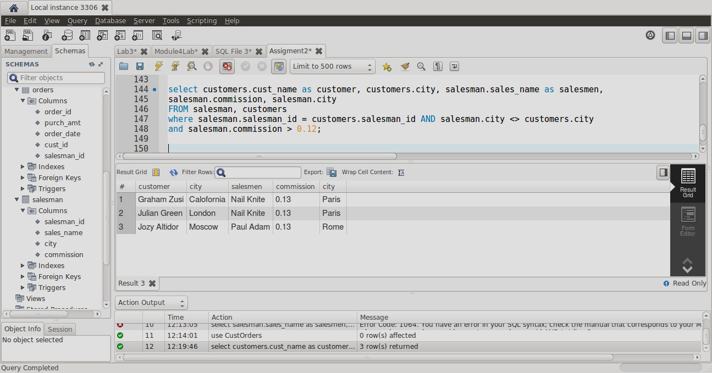

6. Write an SQL statement to find the details of an order i. e. order number, order date, amount of

order, which customer gives the order and which salesman works for that customer and how much

commission he gets for an order.

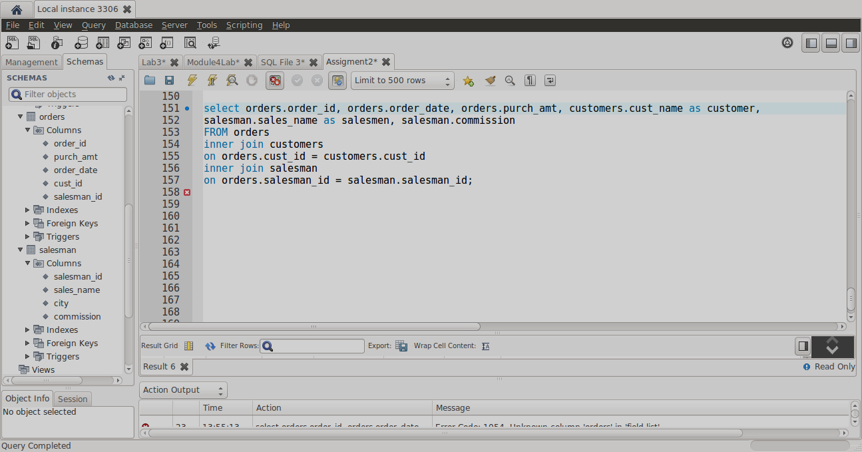

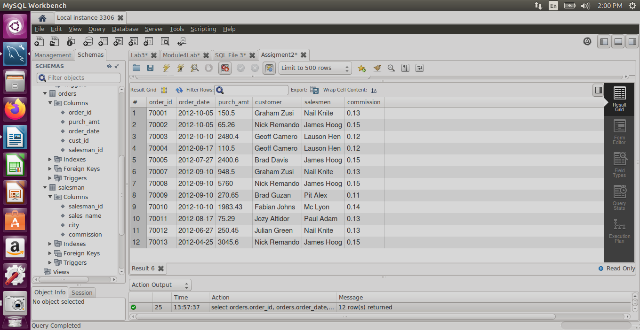

7. Write an SQL statement to make a join within the tables salesman, customer and orders such that

the same column of each table will appear once and only the related rows will be returned.

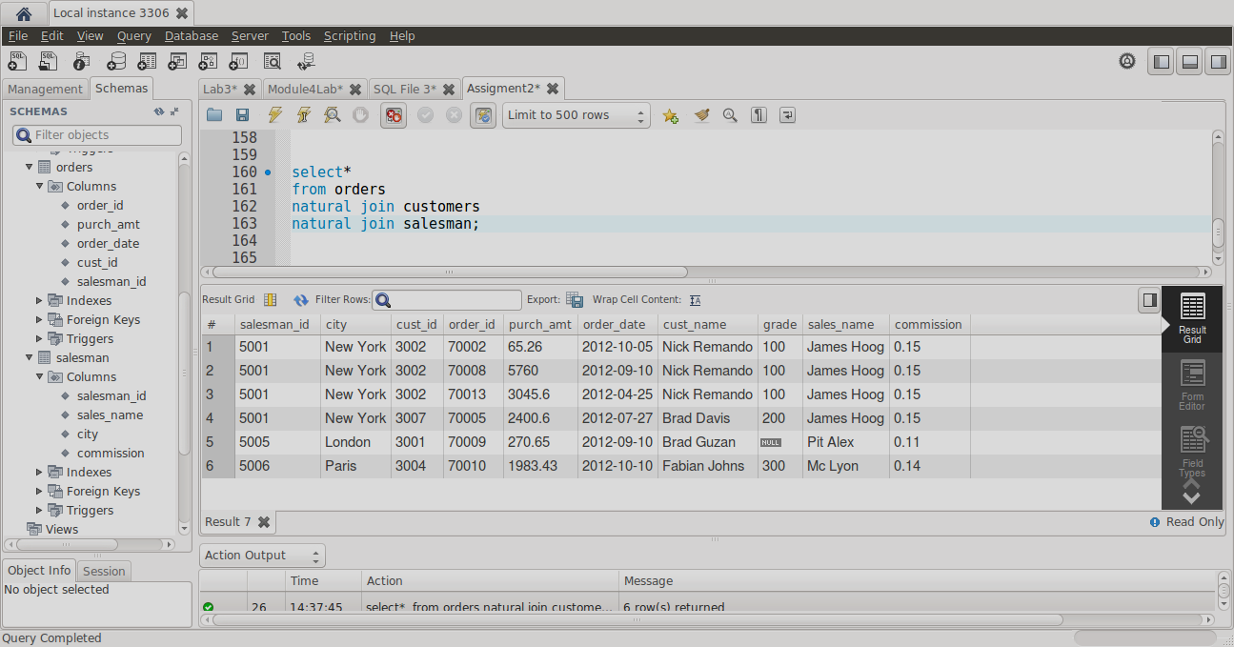

**Question 4**

Having that a Relation can have zero or more Foreign keys and each Foreign key can refer to different

referenced Relations. Specify all possible Foreign keys for this schema

Please see my Schema as below with the all tables and relations, there are 4 FK’s

Table Enroll will have 2FK’s this is a table that connects tables Student and Curse.

Table Book Adoption will have 2FK’s this is a table that connects tables Curse and Text.

